
FUNDING PROPOSAL
Nurse-led, AI-assisted primary healthcare delivered to the home
Seed funding request: R9.7 million
Johannesburg launch · 18-month plan · Gauteng, then national
Prepared by Gilbert Makinana
Founder, MyThuso | Director, Akhanya IT Innovations (Pty) Ltd
gilbert@akhanya.co.za · +27 79 077 1591
September 2026 · Confidential

Contents

A note from the founder
I was born and raised in Gugulethu, Cape Town. My mother still lives there. She is in her late seventies and she lives with several chronic conditions, including a heart condition and high blood pressure. Every month she has to get to the clinic for her check-up and to collect her medicine — a taxi, a queue that can last most of the day, and a long walk home for a woman who should not be standing in a queue at all. I work in Johannesburg. I have tried to get her onto medical aid and, at her age and with her conditions, it is either unaffordable or simply not available.
I lost my father during the COVID years. I will never know for certain whether things could have gone differently, but I believe that if someone with a nurse's training had been checking on him at home, reading his vitals, and able to reach a doctor in minutes, he would have had a far better chance. That belief is the reason this document exists.
There are millions of us in the same position: sons and daughters in the cities who would gladly pay for a trusted person to look after our parents in the townships and villages, and cannot find that person. And there are thousands of qualified nurses and doctors in those same communities who cannot find work. MyThuso puts the two together.
The first MyThuso for Mom customer will be my mother in Gugulethu. Everything in this proposal — the nurses, the doctors, the devices, the medicine delivery, the family reports — is built to answer one question: how do I give my mother a safer, more dignified life under the circumstances we actually live in, and how do I make that possible for every family like mine?
Gilbert Makinana
Founder, MyThuso — Johannesburg, September 2026

MyThuso at a glance
What | Detail
The product | A SANC-registered nurse at the door in under an hour with a connected diagnostic kit; AI screening; doctor sign-off; medicines delivered; a family report after every visit
The hero plan | MyThuso for Mom — R399 / R749 / R1,299 per month, paid by children in the city for parents in townships and villages
Who earns | 500 nurses and 300 doctors as micro-enterprises within 18 months, most previously unemployed or under-employed
The moat | Clinical governance, nurse density, own 5G devices, and a patient-owned Health Passport with a doctor-labelled dataset
The ask | R9.7m seed over 18 months in three milestone-gated tranches; R2m–R5m more from grant and enterprise-development co-funding
The targets | 300 visits/day, 6,000 subscribers, first insurer and pharmaceutical contracts, Cape Town launched in Gugulethu by month 18
Where it goes | Gauteng → Cape Town → rural corridors (Limpopo, Eastern Cape, KZN, North West) → national NHI-aligned primary-care infrastructure

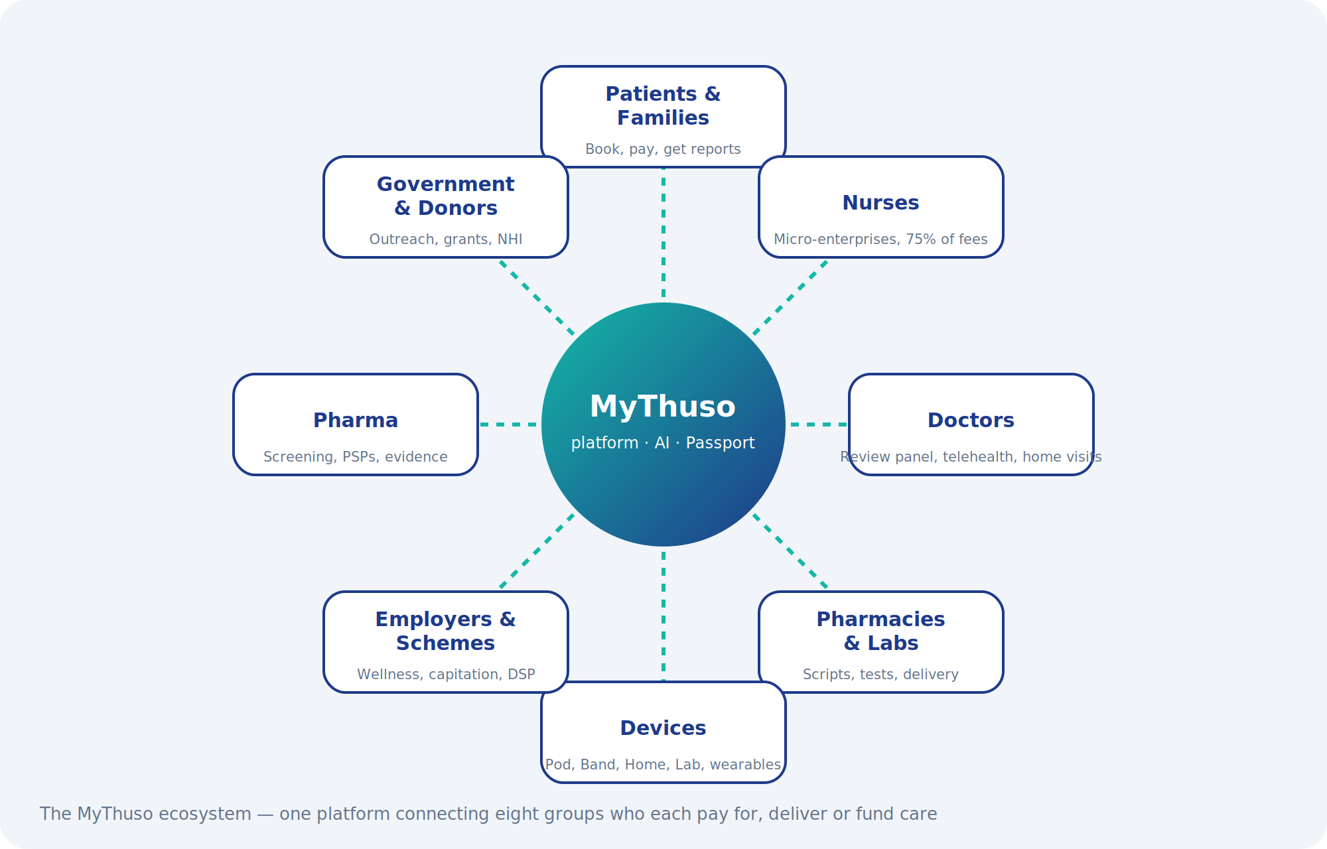

1. Executive summary
A parent in the township or the village with chronic conditions, a clinic that costs a day and a taxi fare, medical aid that will not take her at her age — and a child in the city who would pay for someone trustworthy to look after her. MyThuso is that someone.
MyThuso ("Thuso" means help in Setswana and Sesotho — my help, my health, at home) is an on-demand primary-healthcare platform for South Africa. A SANC-registered nurse arrives at the patient's home in under an hour, carrying a connected diagnostic kit. Vital signs, ECG, blood glucose, wound images, eye images and rapid tests are captured digitally, screened by AI, and reviewed and signed off by a doctor on a telehealth panel. The result is clinic-grade care in the living room, from R249, for the 85% of South Africans without medical aid and the insured households who want convenience.
MyThuso is a marketplace, not a clinic. Nurses are independent partners who keep 75% of visit fees and gain flexible income; patients get fast, fixed-price, verified care; doctors review cases remotely; pharmacies and laboratories fulfil orders through the platform. MyThuso earns on every visit, subscription, script, test, device, policy and corporate contract.
"Help. Health. Home." — a nurse at your door, a doctor on the screen, your record in your pocket.

The ask
We are raising R9.7 million in seed funding to launch in Johannesburg, build the AI-assisted diagnostic layer, design and pilot our own 5G-connected devices, equip 150 nurses with connected diagnostic and sample-testing kits, integrate wearables, and reach 300 visits per day and 6,000 subscribers within 18 months. Use of funds and milestones are set out in Section 18.

Why now
- Public clinics are overloaded: routine tasks such as injections, chronic checks and wound care consume nurse time that should go to complex care.
- Thousands of qualified nurses are unemployed or under-employed and want flexible, dignified income.
- Smartphones, cheap Bluetooth medical devices and AI screening have matured enough to move diagnostics into the home safely.
- National Health Insurance policy is pushing primary care closer to communities; a verified home-visit network with outcomes data becomes contractable infrastructure.
- South Africans have adopted on-demand behaviour (Uber, Sixty60, Mr D). Healthcare has not caught up.

2. The problem
For patients | For nurses | For the health system
4–6 hour clinic queues for a 10-minute task | Thousands unemployed or on short contracts | Clinics overloaded with routine tasks
Taxi fare plus a lost day's wages per visit | Low, fixed agency rates and no flexibility | Poor chronic-disease adherence and high readmissions
No affordable care at home for the elderly, post-operative patients or newborns | No path to grow income or skills | No home-visit data for planning or NHI
Private home nursing costs R600–R1,200 per visit | Isolation and no clinical support network | Late diagnosis of hypertension, diabetes, TB, HIV
Children in the city cannot find anyone trustworthy to care for ageing parents in townships and villages | Rural nurses have no way to earn from the families who would pay them | Pensioners fall through the gap between clinics and unaffordable medical aid

The gap is a high-volume, low-ticket, township-and-suburb service with Uber pricing, Uber speed and hospital-grade governance. Existing home-nursing agencies serve the medical-aid market at premium prices; MyThuso serves everyone.

3. The solution
MyThuso combines four things nobody has put together for the mass market in South Africa:
- A dispatch marketplace — nearest suitable nurse, live ETA, fixed price, OTP-confirmed completion, cash or card.
- A connected diagnostic kit — every nurse carries Bluetooth devices that push readings straight into the patient record.
- AI screening with doctor sign-off — algorithms flag risk; a registered doctor reviews, diagnoses and prescribes remotely. The nurse is the hands, the AI is the filter, the doctor is the decision.
- A patient-owned Health Passport — a portable digital record that grows with every visit and unlocks subscriptions, insurers, employers and government programmes.

Brand positioning
MyThuso is warm, community-rooted and safe. It is not a frail-care agency, not a hospital staffing firm and not concierge medicine. Its promise: Verified nurse · Under an hour · Fixed price · Doctor-reviewed · Insured · Your record, your phone.

The hero product: MyThuso for Mom
The person who pays is usually not the patient. It is the son or daughter in the city with a bank card, looking after a parent in a township or rural village who cannot get to a clinic, cannot afford medical aid and is often excluded from it by age. MyThuso turns that worry into a monthly plan — a remittance for care — delivered by the same nurse every time, with a report to the family after every visit.
Plan | Price per month | What the parent gets
Essential | R399 | Monthly nurse visit (BP, glucose, weight, medicine check, wellbeing), chronic medicine collected and delivered to the door, WhatsApp report and photo to the family after every visit
Plus | R749 | Fortnightly visits, doctor review of every visit, Thuso Band with SOS button, one urgent nurse call-out included, quarterly screening
Premium | R1,299 | Weekly visits, Thuso Home station for video calls with the doctor and the family, pill dispenser, carer hours for bathing and meals, priority SOS, family dashboard

- Add-ons: extra carer hours, physiotherapy, doctor home visit, gift-a-visit, second parent on the same account at a discount; siblings split the bill in the app.
- The report the family can trust: readings, medicines taken, what the nurse saw in the home, a photo, and a doctor flag if anything needs action. Same nurse every visit — she becomes part of the family.
- The medicine problem solved: for public-sector patients the nurse collects from the CCMDD pick-up point or clinic pharmacy with the patient's authorisation and brings it with the visit; private scripts are delivered by partner pharmacies. No more lost days in queues.
- Sold where the children are: taxi ranks, churches, stokvels, employer HR departments, mining hostels, and to South Africans abroad — "look after your parents from here".
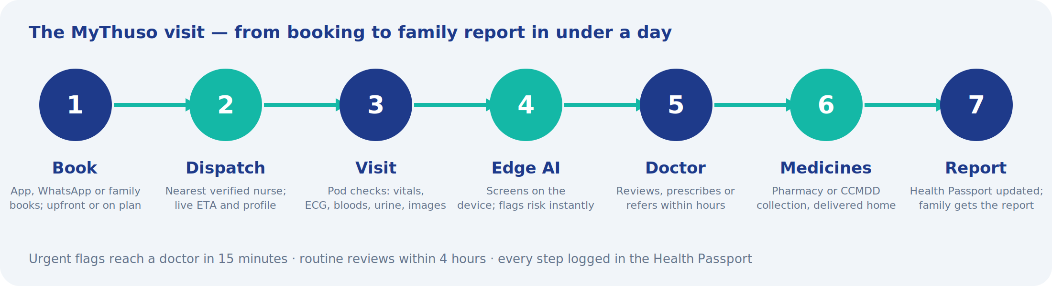

4. Platform architecture
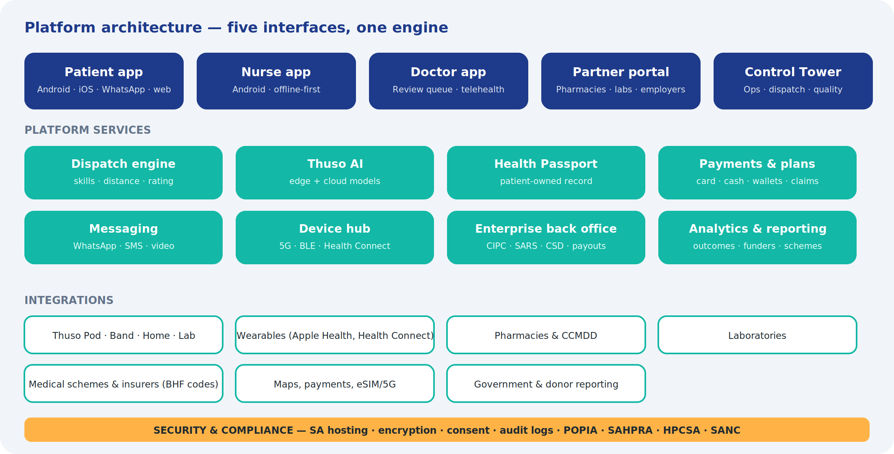
Module | What it does | Phase
Thuso Nurse | On-demand nurse visits: injections, family planning, vitals and chronic checks, wound care, blood draws, post-op, mother and baby, elderly care, sick-note visits | 1
Thuso Doctor | Doctor network: asynchronous review panel, telehealth consults, doctor home visits, micro-clinics and virtual practices — income for unemployed and under-employed doctors | 1–3
Thuso Kit | Connected diagnostic devices carried by every nurse; readings sync to the record | 1
Thuso Devices | Own 5G-connected hardware: Thuso Pod multi-check handheld, Thuso Band wearable, Thuso Home station, Thuso Lab analyser | 3–4
Thuso AI | Screening and decision-support algorithms across vitals, ECG, images, audio and rapid tests; every output reviewed by a doctor | 1–3
Thuso Pass | Patient-owned digital Health Passport with emergency QR card | 2
Thuso Screen | Doctor-reviewed cancer and chronic-disease pre-screening packages for women, men, seniors, families, workers and communities | 2–3
Thuso Wear | Wearable sync via Apple Health and Google Health Connect; continuous vitals feeding Thuso AI between visits | 2
Thuso Pharmacy | Partner pharmacies fulfil e-scripts and adherence packs; own courier licence in year 2 | 2
Thuso Labs | Home sample collection with partner laboratories; results into the Passport | 2
Thuso Routine | Subscriptions: Chronic Routine, Family Planning, Mom, Senior (Gogo), Recover | 2–3
Thuso Family | One account for the household; book and pay for parents and children anywhere in SA; siblings split bills; diaspora sponsorship | 2
Thuso Circuit | Weekly rural nurse routes covering village clusters, planned by the app | 3
Thuso Wallet | Prepaid credits for families, employers, stokvels and churches; vouchers sold in retail and spaza channels | 2
Thuso SOS | Urgent visit under 45 minutes with a doctor on video; panic button for the elderly with ambulance-partner escalation | 2–4
Thuso Corner | Nurse stationed at taxi ranks, spaza shops, churches and estates on fixed days for walk-up screening | 2
Thuso Work | Employer wellness, vaccination drives, chronic support, verified sick notes and sick-note verification API | 3
Thuso Locum | Marketplace for hospitals, clinics and care homes to book vetted nurses for shifts | 2
Thuso Academy | CPD courses, device and AI training, upskilling for Enrolled Nurses and carers | 3
Thuso Money | Weekly payouts, savings pockets, salary advance, equipment finance for nurses (fintech partner) | 3
Thuso Cover | Insurer-backed nurse plan with funeral cover; commission per policy | 4
Control Tower | Live operations map, dispatch, vetting pipeline, incident queue, doctor review queue, quality and revenue | 1

5. Services and value-adds by phase

Layer 1 — Visits (pay-as-you-go)
Service | Price | Nurse share | Phase
Injection / vaccination (on script) | R249 | R187 | 1
Family planning injection | R249 | R187 | 1
Vitals + chronic check (BP, glucose, SpO2, weight, adherence) | R249 | R187 | 1
Wound care / dressing change | R299 | R224 | 1
Blood draw (partner lab) | R299 | R224 | 1
Mother and baby check | R349 | R262 | 1
Post-operative check | R349 | R262 | 1
Elderly care visit (1 hour) | R399 | R299 | 1
Sick-note visit (medical certificate, doctor-reviewed) | R249 | R187 | 1
AI-assisted screening bundle (ECG + vitals + urine + doctor review) | R449 | R300 | 2
Thuso SOS urgent visit (under 45 min, doctor on video) | visit + R99 | premium split 50/50 | 2
Men's health check | R299 | R224 | 2
Mental-health check-in + tele-counsellor | R349 | R262 | 3
Allied health (physio, dietitian, OT, social worker) | R450–R800 | 75% | 3
Home carer (non-nurse, RN-supervised) | R120–R180/hr | 75% | 3
Palliative care (hospice partner) | package | partner split | 4

Layer 2 — Subscriptions (recurring)
Product | Price | Includes | Phase
Chronic Routine | R199/month | Monthly visit, AI-screened vitals, doctor review, CCMDD or pharmacy medicine collection and delivery, adherence nudges | 2
Family Planning Plan | R99/month | Injection every 2–3 months, reminders, discreet booking | 2
Thuso Mom | R249/month | Antenatal visits, immunisation schedule, home visits for baby's first year | 3
MyThuso for Mom — Essential / Plus / Premium | R399 / R749 / R1,299 per month | Elderly parent care paid by the family: nurse visits, medicine collection and delivery, doctor review, Band, Home station, carer hours, family reports | 2–3
Thuso Recover | per package | Post-discharge visits for 2–6 weeks; sold to patients and hospitals | 3
Thuso Alert | R79/month | Panic button dispatching nearest nurse and ambulance partner | 4
Thuso Cover | R99–R199/month | Insurer-backed visit allowance plus funeral cover | 4

Layer 3 — Network and B2B
Product | Buyer | Revenue | Phase
Pharmacy fulfilment and adherence packs | patients | 8–15% of script value | 2
Laboratory tests | patients, insurers | R50–R150 per test | 2
Devices sold or rented to homes (BP monitor, glucometer, oximeter) | patients | margin + rental | 3
Nurse locum marketplace | hospitals, clinics, care homes | 15–20% of shift value | 2
Employer wellness and vaccination drives | employers | R120–R250 per employee per event | 3
Sick-note verification API | employers | per check / licence | 3
Hospital discharge programme | hospital groups | per patient | 3
School health screening | schools | per learner per year | 3
Event medics | organisers | per event | 3
Estate and retirement-village concierge nurse | body corporates | monthly retainer | 3
Sponsored community screenings | pharma, FMCG | campaign fees | 3
Insurer services: remote monitoring, claims verification, low-cost plan wellness | insurers, schemes | per member / per visit | 4
Government and donor programmes: HIV/TB adherence, maternal health, chronic care | DoH, NGOs, donors | contracted service + dashboards | 4
Stokvel, church and corporate wallets | groups, employers | prepaid revenue | 3
Anonymised population-health insights | insurers, government, research | licence (POPIA-first) | 4

6. Thuso AI — tests captured at home, reviewed by doctors
This is the layer that turns a nurse visit into a clinical encounter. Each test below is captured by the nurse with a connected or smartphone-based device, screened by an algorithm, and placed in a doctor review queue. The doctor confirms, orders further tests, prescribes or refers. Nothing is diagnosed by AI alone; AI is clinical decision support and the doctor remains accountable, in line with HPCSA telemedicine guidance. Turnaround target: urgent flags in 15 minutes, routine reviews within 4 hours.
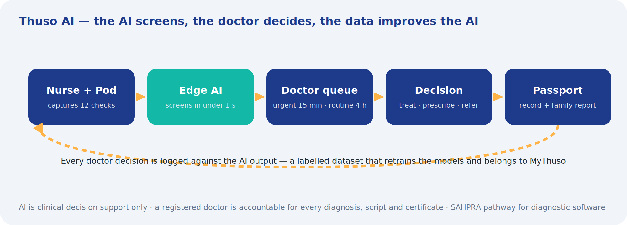
Test | Device / capture | What the AI does | Doctor decides | Phase
Vital-sign risk score | BP cuff, oximeter, thermometer, scale (Bluetooth) | Early-warning score; trend versus patient baseline; flags hypertensive urgency, hypoxia, fever | Treat, refer, adjust chronic meds | 1
Blood glucose and HbA1c | Connected glucometer; point-of-care HbA1c analyser (area kit) | Diabetes control classification and hypo/hyper alerts | Medication changes, dietitian referral | 1
Single-lead ECG | Handheld ECG pad (30-second trace) | Detects atrial fibrillation, bradycardia, tachycardia; quality check | Cardiology referral, anticoagulation review | 2
Wound imaging | Smartphone camera with reference sticker | Measures area and depth trend, detects infection signs, tracks healing week on week | Antibiotics, debridement referral | 2
Skin lesion and rash triage | Smartphone dermatoscope attachment | Prioritises lesions for review; flags suspicious patterns | Dermatology referral, biopsy | 2
Urine dipstick reading | Standard strips read by smartphone camera | Reads 10 parameters objectively; flags infection, protein, glucose, pregnancy | Antibiotics, antenatal action, kidney follow-up | 2
Rapid test reading (HIV, pregnancy, malaria, syphilis, COVID/flu) | Photo of the test cassette | Reads faint lines consistently; timestamps and stores result | Confirmatory testing, treatment initiation, counselling | 2
Anaemia screening | Smartphone photo of eyelid / nail bed, or non-invasive haemoglobin device | Estimates haemoglobin; flags likely anaemia | Full blood count, iron therapy | 2
Cough and lung sound analysis | Digital stethoscope; phone microphone cough recording | Screens for TB-suggestive cough patterns, wheeze, crackles, pneumonia risk | Sputum test, chest X-ray, TB treatment | 3
Diabetic eye screening | Handheld fundus camera (area kit) | Detects diabetic retinopathy and grades severity | Ophthalmology referral, laser treatment | 3
Foot ulcer risk | Camera + monofilament checklist | Predicts ulcer risk in diabetics | Podiatry, footwear, wound plan | 3
Antenatal ultrasound | Handheld ultrasound probe with AI guidance (area kit) | Guides nurse to standard views; estimates gestational age, fetal position, heart rate | High-risk pregnancy referral | 3
Child growth and malnutrition | Scale, height mat, MUAC tape | Plots WHO growth curves; flags stunting and wasting | Nutrition programme, paediatric referral | 3
Medication adherence prediction | Visit history, refill data, self-report | Predicts who will default on HIV, TB or chronic treatment | Adherence counselling, community support | 3
Symptom triage assistant | Patient chat in app or WhatsApp | Structured history in local languages; suggests which service to book | Nurse or doctor confirms | 2

Build, partner or buy
- Phase 1: buy certified devices and licence proven AI models (ECG, retinopathy, dermatology, urine strips, rapid-test readers) from established vendors. Speed and regulatory cover matter more than owning the model on day one.
- Phase 2: build MyThuso's own models where we hold unique data — vital-sign risk scoring for our population, wound-healing trajectory, adherence prediction and the multilingual triage assistant.
- All AI outputs are logged with the doctor's decision, creating a labelled dataset that improves the models and becomes a defensible asset.

Regulatory approach
- AI is deployed as clinical decision support with a registered doctor accountable for every diagnosis, prescription and certificate.
- Devices must be SAHPRA-registered or exempt; software with a diagnostic claim is treated as a medical device and registered accordingly.
- Telehealth follows HPCSA guidelines; nurses act within SANC scope of practice; pharmacies dispense under the Medicines Act; health data is handled as special personal information under POPIA with SA hosting and explicit consent.
- A Clinical Governance Lead (senior nurse) and a Medical Director (doctor) own protocols, incident management and regulator relationships.

7. Devices — Thuso Kit
Every nurse carries a standard connected kit. Higher-cost devices are held as shared "area kits" allocated per zone and booked through the nurse app. In Phase 3 we design our own compact device to reduce cost per kit and lock in the workflow.

Standard nurse kit (per nurse)
Device | Purpose | Indicative cost
Bluetooth upper-arm BP monitor | Hypertension screening and monitoring | R900
Connected glucometer + strips | Diabetes screening and monitoring | R500
Fingertip pulse oximeter (Bluetooth) | Oxygen saturation and pulse | R400
Infrared thermometer | Temperature | R300
Bluetooth scale and height mat, MUAC tape | Weight, BMI, child growth | R600
Handheld single-lead ECG pad | Arrhythmia screening | R2,500
Smartphone dermatoscope clip | Skin and wound imaging | R700
Urine strips, rapid test cassettes (HIV oral and blood, syphilis, pregnancy, malaria, strep, FIT), lancets, sharps container, PPE | Consumables (monthly float) | R800
Peak-flow meter and MUAC tape | Asthma/COPD and child nutrition | R300
Branded bag, ID badge, phone mount, power bank, wound reference stickers | Kit and identity | R1,000
Total per nurse |  | ≈ R8,000

Shared area kit (one per launch zone)
Device | Purpose | Indicative cost
Digital stethoscope with recording | Lung and heart sound analysis, TB screening | R6,000
Point-of-care HbA1c / lipid analyser | Diabetes control and cholesterol on the spot | R25,000
Handheld non-mydriatic fundus camera | Diabetic retinopathy screening | R45,000
Handheld ultrasound probe | Antenatal and basic abdominal scans | R55,000
Non-invasive haemoglobin meter | Anaemia screening | R8,000
Creatinine meter | Kidney function on the spot | R6,000
Pocket urine analyser | Objective 10-parameter strip reading | R6,000
Bluetooth spirometer | Asthma and COPD lung function | R3,500
Total per zone |  | ≈ R160,000

These bought devices get MyThuso to market fast. Section 8 sets out the custom hardware that replaces them from Phase 3.

8. Thuso Devices — our own connected hardware
Off-the-shelf devices are a bag of separate gadgets with separate batteries, apps and calibrations. From Phase 3 MyThuso replaces them with four purpose-built devices designed around the nurse's workflow and the patient's home, built with a South African electronics partner and certified through SAHPRA. Owning the hardware cuts the cost per nurse kit by more than half, locks the workflow to the MyThuso platform and creates a device business in its own right.

Shared technology platform
- 5G / LTE-M eSIM in every device: results upload the moment they are captured, video consults run from the device, and nothing depends on the nurse's phone or the patient's airtime. Automatic fallback to LTE and offline store-and-forward for weak-signal areas.
- Edge AI processor: ECG, image and sound screening run on the device in under a second, so results are available without connectivity and only structured data leaves the home.
- NFC tap-in: the patient's Thuso card or Band identifies them; the nurse logs in by fingerprint. No typing, no wrong-patient errors.
- Secure element and end-to-end encryption; over-the-air updates; remote lock and wipe if a device is lost.
- Load-shedding ready: long-life batteries, USB-C fast charge and solar on the home unit.
- Voice guidance in 11 official languages for nurses and patients; screen-reader accessible.
- Common cartridge and strip format across devices; one supply chain, one calibration standard.

Thuso Pod — the multi-check handheld
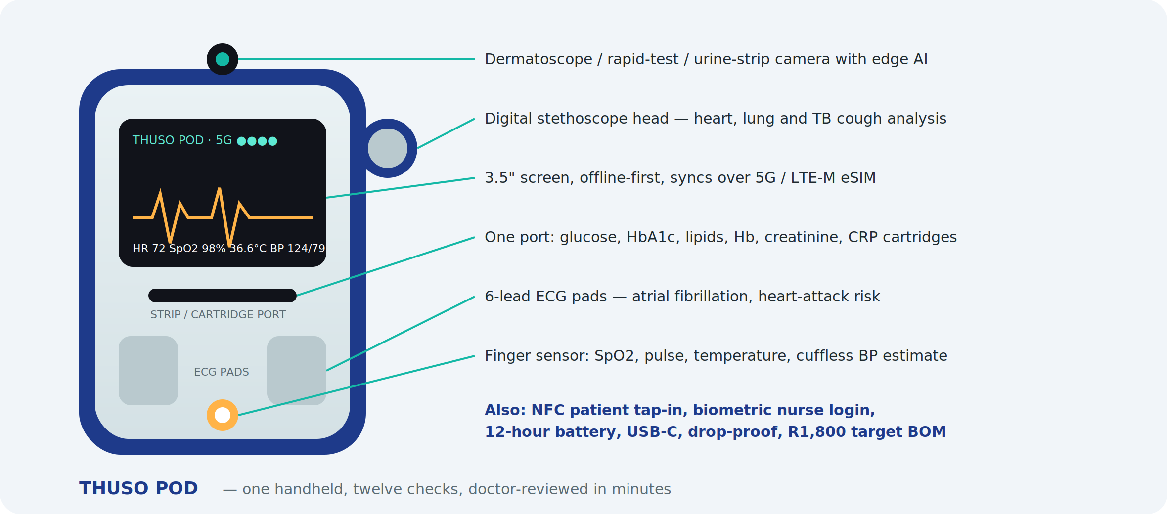
One rugged handheld that performs twelve checks in a single visit: blood pressure (finger-sensor estimate, with an optional Bluetooth cuff for confirmation), SpO2, pulse, temperature, 6-lead ECG, heart and lung sounds, cough analysis, blood cartridges for glucose, HbA1c, lipids, haemoglobin, creatinine and CRP, urine-strip reading, rapid-test cassette reading and dermatoscope imaging. Edge AI flags risk on the spot; the result set reaches the doctor queue over 5G before the nurse leaves. Target bill of materials R1,800 at 1,000 units against roughly R8,000 for the equivalent bought kit.

Thuso Band — the patient wearable
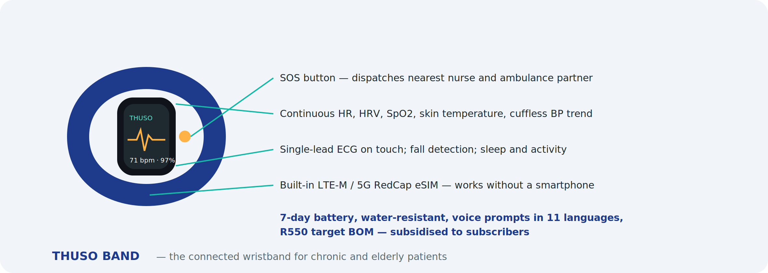
A low-cost wristband for Chronic Routine, Senior and post-discharge patients. Continuous heart rate, HRV, SpO2, skin temperature, cuffless blood-pressure trend, single-lead ECG on touch, sleep, activity and fall detection, with an SOS button that dispatches the nearest nurse and the ambulance partner. A built-in LTE-M / 5G RedCap eSIM means it works for a grandmother with no smartphone. Seven-day battery, water-resistant, voice prompts. Target BOM R550; subsidised to subscribers and sold to employers and insurers.

Thuso Home — the household health station
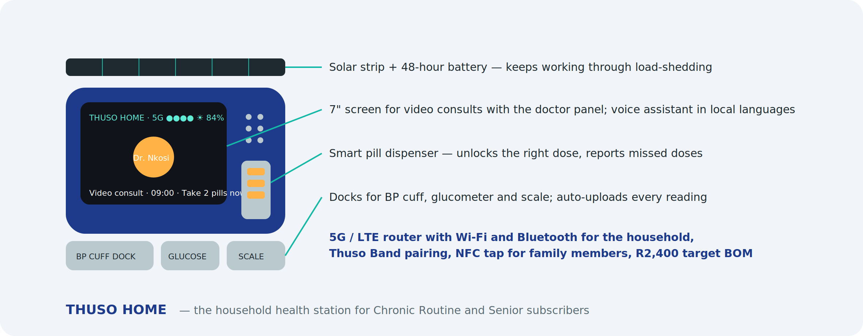
A countertop station for households on subscription: a 7-inch screen for video consultations with the doctor panel, a voice assistant in local languages, a smart pill dispenser that unlocks the right dose at the right time and reports missed doses, docks for the blood-pressure cuff, glucometer and scale that upload every reading automatically, and a 5G router that gives the household Wi-Fi and pairs Thuso Bands. A solar strip and 48-hour battery keep it running through load-shedding. Target BOM R2,400; rented at R99/month inside Chronic Routine and Senior plans.

Thuso Lab — the portable analyser
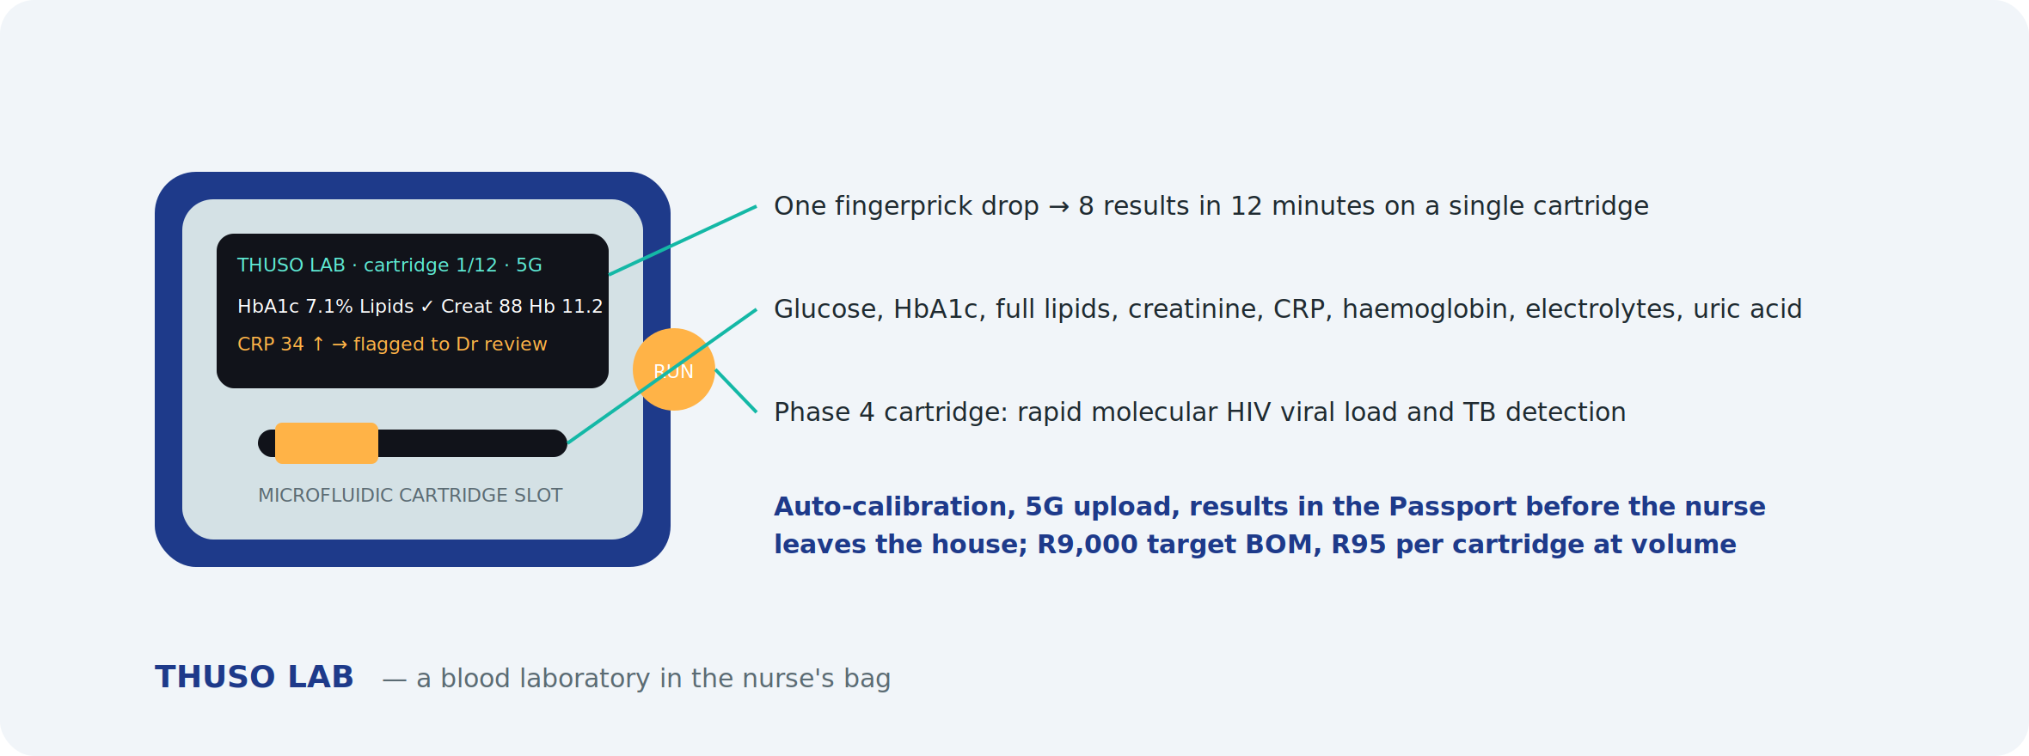
A microfluidic analyser that turns one fingerprick drop into eight results in twelve minutes on a single cartridge: glucose, HbA1c, full lipids, creatinine, CRP, haemoglobin, electrolytes and uric acid. Self-calibrating, 5G-connected, results straight into the Health Passport. A Phase 4 molecular cartridge targets rapid HIV viral load and TB detection at the bedside. Target BOM R9,000; R95 per cartridge at volume against R150–R250 for bought equivalents.

Roadmap and cost
Device | Design and prototype | Certification (SAHPRA, ICASA) | Pilot run (200 units) | Total to pilot
Thuso Pod | R550,000 | R180,000 | R360,000 | R1,090,000
Thuso Band | R220,000 | R90,000 | R110,000 | R420,000
Thuso Home | R180,000 | R60,000 | R100,000 | R340,000
Thuso Lab (Phase 4, Series A) | R900,000 | R250,000 | R450,000 | R1,600,000 (not in this round)

This round funds Pod, Band and Home to pilot (R1.85m). Thuso Lab and volume manufacturing are Series A items. Design partner selection, industrial design and firmware start in month 10; SAHPRA submission in month 15; pilot units in nurses' hands by month 18.

What the hardware unlocks
- Kit cost per nurse falls from about R8,000 to under R3,500, so scaling to 5,000 nurses becomes affordable.
- Device rental and cartridge sales become a recurring revenue line independent of visits.
- Insurers, employers and government programmes can buy Thuso Band and Thuso Home as remote-monitoring products.
- The device and its data are MyThuso's; a competitor cannot copy the workflow by buying the same gadgets online.
- Export potential across Africa where the same connectivity and load-shedding realities apply.

9. Sample testing and wearables — urine, stool, mouth, blood
A nurse visit can capture most of what a clinic collects. Rapid tests and point-of-care analysers give results in minutes; anything needing a laboratory is collected at home and sent through Thuso Labs. Every result is stored in the Health Passport and, where it carries a diagnosis, reviewed by a doctor.

What each sample gives us
Sample | At home (minutes) | To the laboratory (Thuso Labs) | Conditions screened
Urine | 10-parameter dipstick read by phone camera or pocket analyser: glucose, protein, ketones, blood, nitrites, leukocytes, pH, specific gravity, bilirubin, urobilinogen; hCG pregnancy; microalbumin; drug screen | Culture and sensitivity, cytology, albumin-creatinine ratio | UTI, diabetes control, kidney disease, dehydration, pre-eclampsia, pregnancy, substance use
Stool | FIT (hidden blood), H. pylori antigen, rotavirus/adenovirus, calprotectin | Parasites, culture, microbiome | Colorectal cancer screening, ulcers, child diarrhoea, inflammatory bowel disease
Mouth and saliva | Oral-swab HIV, COVID/flu antigen, strep A throat swab, saliva drug test; phone photo for AI oral-cancer and dental screening | Cortisol and hormone panels, genetic tests | HIV, respiratory infection, strep throat, oral cancer, dental disease
Blood (fingerprick) | Glucose, HbA1c, lipid panel, haemoglobin, HIV/syphilis duo, hepatitis B/C, malaria, CRP, creatinine, INR; multi-analyte chemistry panel on the area analyser | — | Diabetes, cholesterol, anaemia, HIV, syphilis, hepatitis, malaria, infection, kidney function, warfarin control
Blood (venous draw) | Collected by nurse | Full blood count, kidney and liver function, thyroid, PSA, vitamin D, iron studies, CD4, viral load, tumour markers | Broad diagnostic and monitoring panels
Breath and lungs | Bluetooth spirometer, peak flow, breathalyser, cough recording | — | Asthma, COPD, TB risk, occupational alcohol screening

Consumable and analyser costs
Item | Indicative cost
Urine strips (10-parameter) | R3 per strip; pocket analyser R6,000 (optional; phone reading is free)
Microalbumin strip / hCG strip / drug-screen cup | R25 / R15 / R80
FIT / H. pylori / rotavirus / calprotectin rapid kits | R120 / R60 / R70 / R250
Oral HIV swab / COVID-flu / strep A / saliva drug test | R80 / R60 / R50 / R120
HIV-syphilis duo / hepatitis B-C / malaria / CRP rapid | R45 / R50 / R30 / R60
HbA1c analyser and cartridge | R25,000 + R60 per test
Lipid panel cartridge (same analyser) | R120 per test
Haemoglobin meter and cuvettes | R3,500 + R15 per test
Creatinine meter and strips | R6,000 + R80 per test
Multi-analyte chemistry analyser (area kit, Phase 3) | R60,000 + R150 per panel
Bluetooth spirometer / peak-flow meter / breathalyser | R3,500 / R300 / R800

Tests are priced to the patient at consumable cost plus a margin and, where relevant, the doctor review — for example a fingerprick HIV/syphilis test at R79, a FIT screening at R199 and an HbA1c at R249 inside the AI-screening bundle. Employer, insurer and government programmes buy tests in volume.

Wearables
MyThuso syncs with Apple Health (Apple Watch) and Google Health Connect (Samsung Galaxy Watch, Fitbit, Huawei, Xiaomi, Garmin, Oura). Data captured continuously between visits:
- Heart rate, heart-rate variability, resting heart rate trends
- Blood-oxygen saturation, especially overnight
- Single-lead ECG and irregular-rhythm notifications (Apple, Samsung)
- Cuff-calibrated blood-pressure trends (Samsung)
- Sleep, steps, activity and skin temperature
- Fall detection for elderly subscribers
Consumer wearables are not diagnostic devices, so Thuso AI treats them as trend data: a rising resting heart rate or falling overnight SpO2 in a Chronic Routine patient triggers a nurse visit and a doctor review rather than a diagnosis. Commercially, MyThuso subsidises a R700 band for Chronic Routine and Senior subscribers and offers employers and insurers a wearable-linked wellness tier.
Wearable option | Indicative cost | Role
Xiaomi-class smart band | R700 | Subsidised to subscribers: heart rate, SpO2, sleep, steps
Samsung Galaxy Watch | R4,500–R7,000 | ECG, BP trends, fall detection; premium subscribers and Senior plan
Apple Watch SE | from R6,500 | ECG, irregular rhythm, fall detection; iPhone users
Fitbit / Garmin | R2,500–R6,000 | Wellness tiers for employers
Health Connect and Apple Health integration | R150,000 once-off | Development, consent flows, data mapping into the Passport

10. Thuso Screen — pre-screening programmes
South Africa's biggest killers — cervical, breast, colorectal and prostate cancer, heart disease, stroke, kidney failure, TB and HIV — are caught late because almost nobody is screened. Thuso Screen turns the nurse visit into a structured, doctor-reviewed screening programme with an automatic referral pathway and a report in the Health Passport.

Cancer screening
Cancer | How we screen at home | Follow-up pathway
Cervical | HPV self-sampling swab collected by the woman, sent to the lab (WHO-recommended route; reaches women who avoid pap smears) | Positive → colposcopy referral
Breast | Clinical breast exam by nurse, handheld pressure-sensor breast scanner (no radiation, minutes), risk questionnaire | Suspicious → mammogram / ultrasound
Colorectal | FIT stool kit from age 45, earlier with family history | Positive → colonoscopy
Prostate | PSA fingerprick rapid test or lab PSA plus symptom score, from age 45 (40 with family history) | Raised → urology
Oral | Nurse visual exam and phone photo for AI lesion screening; targets smokers and snuff users | Lesion → ENT / dental biopsy
Skin | Dermatoscope photos, AI-prioritised, doctor-reviewed | Suspicious → dermatology
Lung | Symptom and exposure questionnaire, cough recording, spirometry; smokers, miners, TB survivors | High-risk → chest X-ray / CT
HIV-linked cancers | Skin and oral check for Kaposi sarcoma and lymphoma signs in HIV-positive patients | Referral

Other pre-screening
Area | Screen | Devices / tests
Cardiovascular and stroke | 10-year risk score; atrial fibrillation | BP, lipids, glucose, single-lead ECG
Kidney | Diabetic and hypertensive kidney disease | Creatinine meter, urine microalbumin
Liver | Hepatitis and alcohol-related risk | Hepatitis B/C rapid tests, AUDIT questionnaire
TB and HIV | Symptom screen, cough analysis, testing | Oral/fingerprick HIV, sputum referral
Mental health | Depression and anxiety in local languages | PHQ-9, GAD-7, tele-counsellor referral
Cognitive decline | Over-60s in the Senior plan | 5-minute cognitive screen
Osteoporosis and falls | Elderly risk and balance | Risk questionnaire, timed-up-and-go test
Vision and hearing | Acuity and audiometry | Phone acuity app, headphone audiometry; optometry and hearing-aid referrals
Child development | Growth, nutrition, milestones, immunisation gaps | Scale, MUAC, growth curves
Antenatal risk | Hypertension, anaemia, infection, gestational diabetes | BP, urine protein, haemoglobin, HIV/syphilis, glucose
Occupational health | Fitness-for-work panels for mines, factories, transport | Spirometry, audiometry, vision, drug and alcohol screens

Screening packages
Package | Includes | Price
Women's Screen | HPV self-sample, breast exam and scanner, BP, glucose, HIV, anaemia, PHQ-9 | R699
Men's Screen | PSA, FIT, BP, lipids, glucose, HIV, oral and skin check | R649
Senior Screen | Cardiovascular, kidney, cognitive, fall risk, vision, hearing, FIT | R799
Family Screen | Two adults and children: growth, immunisation, BP, glucose, HIV | R999
Worker Screen | Occupational panel per employee | R350–R550
Community Screen | Sponsored Thuso Corner day: BP, glucose, HIV, cervical and breast sign-up | sponsor-funded

Screening devices and tests (additional to the kits above)
Item | Indicative cost
HPV self-sampling kit + lab processing | R280 per test
Handheld breast scanner (area kit) | R65,000 per zone
PSA rapid test / lab PSA | R90 / R180 per test
Audiometry headphones and app licence | R2,500 per zone
Questionnaire and cognitive screen licences | included in platform

Screening is also MyThuso's strongest institutional story: insurers pay for early detection, employers pay for occupational panels, and the Department of Health and donors fund cervical, breast, TB and HIV screening at population scale. Every screen produces structured, anonymisable data on disease burden by area.

11. Thuso Doctor Network — income for South Africa's doctors
Every year hundreds of doctors complete community service and cannot find posts, while many general practitioners in private practice are squeezed by scheme tariffs, indemnity costs and administration. MyThuso gives doctors income from day one without rooms, staff or debt, and gives the platform the clinical authority that makes AI screening safe. This is a jobs story as much as a health story.

Five ways doctors earn on MyThuso
Role | What the doctor does | Earnings | Phase
Review panel (asynchronous) | Works through the AI-flagged queue — vitals, ECGs, wound and skin images, rapid tests, sick-note requests — signs off, prescribes or refers from anywhere | R40–R60 per case; 60 cases in a few hours ≈ R2,500–R3,500 per day | 1
Telehealth consults | Video consult inside the nurse visit or direct from the app | R199 consult, doctor keeps R140 | 2
Doctor home visits | Thuso Doctor at home for complex, elderly, post-operative and palliative patients, with Pod data already on screen | R549–R699 per visit, doctor keeps 75% | 3
Thuso Corner micro-clinic | Doctor plus two nurses at a taxi rank, church or estate on fixed days — a practice with no lease | Per-session fee plus consult share | 3
Virtual practice | Doctor builds a panel of chronic patients; MyThuso handles bookings, billing, scheme claims, group indemnity and the nurse workforce | Capitation and consult income; "your first practice without the debt" | 3

- Salaried and contract roles: Medical Director, area clinical leads, protocol authors, AI-labelling and audit doctors, doctor locum marketplace alongside the nurse one.
- Barriers removed: group professional indemnity, no practice overheads, flexible hours, claims and admin handled by the platform, CPD through Thuso Academy.
- Recruitment partners: JUDASA (junior doctors), SAMA, medical-school alumni networks, provincial health departments at the end of each community-service cycle.
- Target: 20 doctors at launch, 100 by month 9, 300 by month 18 — the majority previously unemployed or under-employed.
"Your first practice, without the debt."

12. Pharmaceutical and medical-scheme partnerships
Pharmaceutical companies and medical schemes each spend heavily on problems MyThuso solves as a by-product of ordinary operations: finding undiagnosed patients, keeping them on treatment, and keeping them out of hospital. These partnerships are the largest revenue lines in the plan after year one and the reason the platform can afford to serve uninsured patients at low prices.

What pharmaceutical companies buy
Need | MyThuso product | Commercial model
Undiagnosed patients (hypertension, diabetes, HIV, asthma, cholesterol) | Sponsored community screening days at Thuso Corners with structured referral into treatment | Campaign fees R50k–R250k per campaign
Adherence to chronic and specialty medicines | Patient Support Programmes delivered by MyThuso nurses: adherence visits, reminders, side-effect monitoring, refill delivery | R150–R400 per patient per month
Real-world evidence for market access and regulators | Anonymised, consented outcomes and adherence data by area and therapy | Data licences (POPIA-first)
Faster clinical-trial recruitment | Verified, geo-tagged patient base and nurse-run home follow-up for trial sites | Per enrolled patient; per follow-up visit
Diagnostics volume | Analysers placed in area kits and Thuso Lab cartridges | Subsidised hardware from diagnostics companies in return for consumable volume

Targets: Aspen, Adcock Ingram and Cipla SA for high-volume chronic generics; Sanofi, Novartis, Novo Nordisk, AstraZeneca and Pfizer for chronic and specialty programmes; Abbott, Roche Diagnostics and Siemens Healthineers on the diagnostics side. Route in through heads of market access and medical affairs, and through IPASA and the Pharmaceutical Task Group.

What medical schemes and insurers buy
Need | MyThuso product | Commercial model
Lower chronic-disease cost and PMB compliance | Chronic capitation: home management of hypertension, diabetes, HIV, asthma members with outcomes reporting | R120–R250 per member per month
Fewer hospital admissions and readmissions | Hospital-at-home and post-discharge packages; each avoided readmission saves R30k–R80k | Per patient episode
Affordable primary-care benefit options | MyThuso as the delivery arm for low-cost benefit options and health-insurance products | Per visit or capitation
Member wellness and screening | Thuso Screen packages and Thuso Band monitoring as a member benefit; Health Passport as the member record | Per member per year
Claims integrity | Verified sick notes and home-visit claims verification | Per check

Sequence: start with health-insurance products that buy per visit and decide fast (Dis-Chem Health, Kaelo, Affinity, Essential Med); then mid-size schemes (Bonitas, Medihelp, Bestmed); then Discovery Health and Momentum. In parallel, prepare for GEMS — more than two million government-employee beneficiaries, a stated primary-care focus and procurement by tender. Prerequisites in Phase 1: BHF practice numbers for nurses and doctors so visits are claimable, CMS-compliant billing, and designated-service-provider agreements.

Lobbying and advocacy plan
- Month 1: Clinical Advisory Board with representatives from SAMA or JUDASA, DENOSA, a scheme medical adviser and a pharmaceutical market-access veteran.
- Month 6: six-month pilot data pack — doctors and nurses employed, patients diagnosed, adherence rates, readmissions avoided, cost per outcome.
- Months 6–12: presentations to IPASA members, the Board of Healthcare Funders, scheme medical advisers, and the Council for Medical Schemes on low-cost benefit options.
- Months 6–12: engagement with the National Department of Health, provincial departments and the NHI office on contracting MyThuso as community primary-care capacity, and with the Department of Employment and Labour on health-worker job creation.
- Ongoing: publish outcomes with a university partner to build the evidence base that schemes and government require.

13. Health micro-enterprises and government co-funding
MyThuso structures every nurse, doctor and carer on the platform as a registered micro-enterprise — the model that works for artisans and tradespeople. The platform becomes their back office: company and tax registration, CSD listing, a bank account, invoicing, indemnity, training and tools of trade. That structure makes each of them eligible for government and corporate enterprise-development funding that already exists for exactly this purpose: putting unemployed health workers to work and equipping township and rural businesses.

The nurse and doctor enterprise programme
Element | How it works on MyThuso
Micro-enterprise registration | CIPC, SARS, CSD and bank account opened through the app; MyThuso handles invoicing, claims and compliance renewals
Tools of trade | Starter kit and later the Thuso Pod on rent-to-own deducted from weekly earnings; owned after 12 months; grant-funded for those who qualify
Earn while you learn | Carer and Enrolled Nurse learnerships with stipends through Thuso Academy (HWSETA-accredited), progressing to Registered Nurse
Verified profile and rating | SANC or HPCSA number, police clearance, training badges, reliability score, patient ratings
Guaranteed pay | Patient pays upfront or on the plan; provider paid weekly; no chasing families for money
Insurance bundle | Professional indemnity and income protection at group rates
Supplier discounts | Uniforms, consumables, phones and data at negotiated prices
Co-operatives | Nurses in an area form a co-op to access DSBD funding and to bid for provincial contracts collectively
Progression ladder | Carer → Enrolled Nurse → Registered Nurse → Area Lead → Circuit owner

Government and enterprise-development funding sources
Programme | What it funds | How MyThuso uses it | Indicative value (18 months)
HWSETA discretionary grants | Learnerships, internships, skills programmes, stipends | Thuso Academy training; EN and carer learnerships; stipends for new nurses in their first six months | R1.5m–R3m
UIF Labour Activation Programme | Training and placement of the unemployed | Onboarding and placement of unemployed nurses and doctors | R0.5m–R1.5m
Jobs Fund (National Treasury) | Matched funding for proven job-creation models | 1:1 match against 800 nurse and doctor jobs | R3m–R8m (match to seed round)
YES — Youth Employment Service | Corporate-funded 12-month youth placements for B-BBEE points | Youth runners, carers, dispatchers and Thuso Corner assistants at no cost to MyThuso | R1m–R2m in funded salaries
NYDA grants | Youth-owned micro-enterprises | Kit grants for nurse and doctor enterprises under 35 | R30k–R100k per enterprise
DSBD / sefa — Township and Rural Entrepreneurship Programme, asset finance | Tools of trade and equipment for township and rural businesses | Pods, Bands, bags and analysers as tools of trade; rent-to-own book funded by sefa | R1m–R3m
Corporate ESD spend (B-BBEE scorecard) | Enterprise and supplier development of black-owned SMMEs | Corporates sponsor nurse kits and working capital; MyThuso as ESD programme partner | R0.5m–R2m per corporate
TIA, SPII and DTIC incentives | Technology R&D and local manufacturing | Thuso Pod, Band and Home development and manufacturing | R1m–R3m
Department of Social Development | Subsidies for home-based care of older persons via registered NPOs | An NPO arm delivers subsidised MyThuso for Mom visits to pensioners who cannot pay | Per beneficiary subsidy
Provincial DoH and NHI | Community health worker and outreach contracts | Thuso Circuits contracted as outreach capacity | Contract-based
Tax incentives (s12H learnership allowance, Employment Tax Incentive) | Reduces cost of employing and training | Applied to every learner and young employee | R0.3m–R0.6m

Realistically, R2m–R5m of the first 18 months' costs can be met from these sources without equity, and a Jobs Fund match alone could double the seed round. The proposal to government is simple: MyThuso creates 800 health micro-enterprises in 18 months, equipped with tools of trade, in townships and villages, at a fraction of the cost of a clinic post.

How we approach it
- Month 1–3: register MyThuso on CSD; register the NPO arm; open the HWSETA discretionary-grant and UIF LAP applications; appoint an enterprise-development partnerships lead (shared with the pharmaceutical and scheme role).
- Month 3–6: first corporate ESD partner sponsoring 50 nurse kits; YES placements for 20 youth; NYDA and sefa applications for the first cohort of nurse enterprises.
- Month 6–12: Jobs Fund application with pilot data; DSBD TREP application for rural Circuit kits; TIA/SPII for Thuso Pod.
- Month 12–18: DSD home-based care subsidy for the NPO arm; provincial DoH outreach contract pilot.

14. Business model
Unit economics on a R299 visit: patient pays R299 → nurse receives R224 → payment costs R9 → MyThuso retains about R66. Doctor review is paid per case (R35–R60) from the AI-screening bundle and subscription margin.

Revenue streams
- 25% of every visit
- Subscriptions: Chronic Routine, Family Planning, Mom, Senior, Recover, Alert
- AI-screening bundles, Thuso Screen packages and doctor reviews
- Pharmacy, laboratory, rapid-test and device commissions
- Wearable-linked wellness tiers for subscribers, employers and insurers
- Nurse locum marketplace fees
- Employer, school, estate, hospital and event contracts
- Insurance and funeral commissions
- Vouchers, prepaid wallets and group plans
- Pharmaceutical partnerships: sponsored screening, patient support programmes, real-world evidence, trial recruitment
- Medical scheme and insurer contracts: chronic capitation, hospital-at-home, benefit-option delivery
- Government and donor programme contracts
- Grant and enterprise-development co-funding (HWSETA, UIF LAP, Jobs Fund, YES, DSBD, ESD, TIA) offsetting training, kits and stipends
- Nurse-side: Academy, Store, fintech commissions
- Anonymised data insights (year 2, POPIA-first)
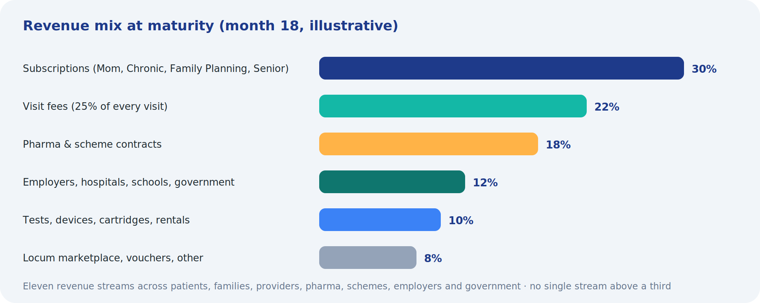

Indicative trajectory
Point | Visits/day | Subscribers | Monthly revenue | Monthly costs | Net
Month 5 (launch) | 30 | – | R55k | R190k | –R135k
Month 9 | 100 | 2,000 | R360k | R280k | +R80k
Month 15 | 300 | 6,000 | R1.15m | R520k | +R630k
Month 24 (Gauteng + Cape Town) | 600 | 14,000 | R2.6m | R1.1m | +R1.5m
Year 3 (3 cities) | 1,000 | 20,000 | R4.0m | R1.6m | +R2.4m

Revenue includes retained visit margin, subscription margin after nurse and delivery costs, AI bundles, pharmacy, labs, locum and B2B. Costs include clinical and medical leadership, support, doctors' review fees, technology, insurance, marketing and device depreciation.

15. Market
- About 50 million South Africans have no medical aid and depend on public clinics; roughly 9 million have medical aid and increasingly want convenience.
- Hypertension, diabetes, HIV and TB together affect well over 15 million people who need regular monitoring and medication — the core of Chronic Routine.
- More than a million births a year and a growing elderly population drive Mom and Senior subscriptions.
- South Africa has hundreds of thousands of registered nurses; a meaningful share are unemployed, part-time or seeking extra income.
- Corporate wellness, insurers seeking low-cost plan benefits, hospitals reducing readmissions and government programmes are large institutional buyers.
Initial focus: Johannesburg zones with high density and mixed income — Soweto, Roodepoort/Randburg, Tembisa/Kempton Park — then Pretoria, Ekurhuleni, Cape Town and Durban.

Reaching rural parents — Thuso Circuit
Townships are day one; rural villages are phase two, and they are reachable because the nurses are already there: clinic nurses off shift, retired nurses, and nurses who went home when they could not find work in the cities. A Thuso Circuit nurse covers a cluster of villages on a weekly route planned by the app, carrying the Pod so every check is done on the spot. Thuso Band's own eSIM means the parent needs no phone or data; the Thuso Home station's solar strip keeps it working when the grid does not.
- Corridor strategy: Cape Town townships (Gugulethu, Nyanga, Khayelitsha) from month 13, starting in Gugulethu where the founder's mother lives; then expand along the routes Johannesburg's workforce comes from — Limpopo (Giyani, Thohoyandou, Burgersfort), Eastern Cape (Mthatha, Butterworth), KwaZulu-Natal (Nongoma, Ulundi), North West (Taung, Mahikeng) — one province per quarter from month 12, seeded by children already paying in Johannesburg.
- Rural pricing is the same for the family; nurse density is built by paying a route retainer until visit volume covers it.
- Government and donor alignment: care for pensioners in rural areas is what the state cannot deliver and what families will pay for — the strongest possible case for co-funding.

16. Go-to-market and take-off plan

First 90 days
Days | Focus | Outcomes
1–30 | Company, Clinical Governance Lead, Medical Director, protocols, insurance, POPIA, pharmacy and lab partners, v1 build, nurse recruitment opens | Foundation in place; 100 nurse applications
31–60 | Vet and train 50 RNs; issue kits; doctor panel of 5; friends-and-family pilot of 100 visits; support team hired | Zero-incident pilot; pricing and menu finalised
61–90 | Public launch in three zones; first-visit offer; first Thuso Corner; referral rewards | 15–30 visits/day

Eighteen-month roadmap
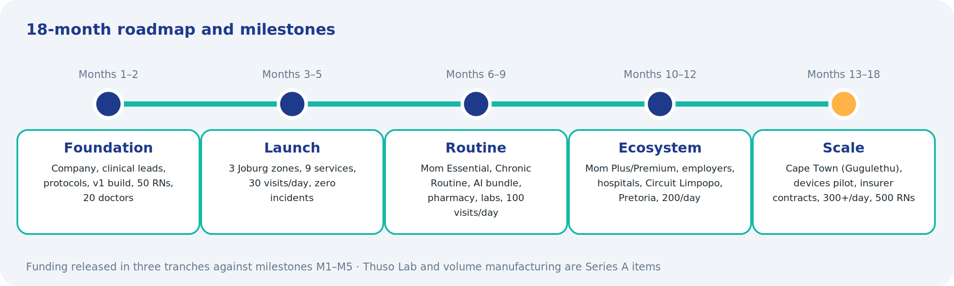
Months | Milestones
1–2 | Foundation, build, recruit: 50 RNs vetted, v1 live, 5 doctors on panel
3–5 | Launch nine core services incl. family planning; 30 visits/day; 500 visits with zero unresolved incidents
6–9 | MyThuso for Mom Essential in Soweto and Tembisa; Chronic Routine and Family Planning Plan; pharmacy delivery; labs; ECG, wound, urine and rapid-test AI live; Health Passport; locum marketplace; five Thuso Corners; Play Store app; 100 visits/day, 2,000 subscribers, 150 RNs
10–12 | Thuso Mom; MyThuso for Mom Plus and Premium; first rural Thuso Circuit (Limpopo); employer wellness; hospital discharge pilot; school health pilot; Academy; Enrolled Nurses and carers; Pretoria and Ekurhuleni; 200 visits/day, 4,000 subscribers
13–18 | Retinopathy, lung-sound and ultrasound AI with area kits; insurer partner; Thuso Pod design; Cape Town launching in Gugulethu, Nyanga and Khayelitsha; 300+ visits/day, 6,000+ subscribers, 500 RNs

Demand engine
- Trusted nodes: pharmacies (script-linked visits), churches, stokvels, estate managers, taxi ranks, spaza shops and clinics referring overflow.
- Thuso Corners for walk-up screening and sign-up.
- Vouchers in cash channels; family and diaspora sponsorship ("book a nurse for Mom").
- Community radio, WhatsApp groups, local Facebook and referral rewards.
- B2B sales from month 6: locum, employers, hospitals, schools, estates, insurers.

17. Clinical governance and regulation
- Nurses: SANC-registered with a current annual practising certificate, verified at onboarding and annually; Registered Nurses only at launch; Enrolled Nurses and carers under RN supervision from Phase 3.
- Scope: every service mapped to SANC scope of practice; injections and medicines only on valid prescription; diagnosis and prescribing by the doctor panel.
- Doctors: HPCSA-registered, contracted to the review panel, working under HPCSA telemedicine guidelines and a Medical Director.
- Medicines: dispensing and delivery only through licensed pharmacies.
- Protocols at launch: injection administration, wound care, vitals and chronic check, phlebotomy, post-operative assessment, mother and baby check, elderly assessment, medical certificate criteria, infection control and sharps, emergency escalation and referral, device use and AI result handling.
- Vetting: SANC, ID, police clearance, references, skills assessment, practical sign-off, four hours online and one day practical training including device and AI workflow.
- Insurance: professional indemnity per nurse (group scheme), doctor indemnity, platform public liability, cyber cover.
- POPIA: health data as special personal information; explicit consent, SA hosting, encryption at rest and in transit, role-based access, audit logs, Information Officer, retention policy; patient owns and can export the Passport.
- Incident management: escalation acknowledged within 5 minutes, Clinical Lead review within 24 hours, transparent reporting.
- Regulator engagement: early meetings with SANC, HPCSA, SAHPRA, Gauteng Department of Health and DENOSA, positioned as decongesting clinics and creating nurse employment.

18. Use of funds, milestones and financial plan

Seed round: R9.7 million over 18 months
Category | Amount | Detail
Clinical and medical leadership | R1,200,000 | Clinical Governance Lead, Medical Director (part-time), nurse community manager, area supervisors
Doctor review panel | R650,000 | Per-case review fees during ramp-up before bundle revenue covers them
Technology and AI | R1,650,000 | Patient, nurse, partner and Control Tower apps; AI model licences and integration; own-model development; Apple Health and Google Health Connect wearable integration; hosting; security and POPIA
Devices and test consumables | R2,200,000 | 150 standard nurse kits (R1.2m), three shared area kits incl. breast scanners (R680k), 12-month sample and screening consumable float (R220k) and 500 subsidised wearable bands (R100k)
Thuso Devices — Pod, Band, Home to pilot | R1,850,000 | Industrial design, firmware, prototypes, SAHPRA and ICASA certification, 200-unit pilot runs with a local electronics partner
Operations and support | R700,000 | Dispatch and support team, training, kit logistics
Marketing and community activation | R650,000 | Thuso Corners, trusted-node partnerships, vouchers, radio, digital, launch offers
Regulatory, legal, insurance | R420,000 | Company setup, contracts, indemnity and liability cover, SAHPRA and POPIA compliance, attorney
Contingency | R380,000 | About 5% of the round
Total | R9,700,000

Milestones that gate spending
Milestone | Target | Releases
M1 | 50 vetted RNs online, v1 live, 5 doctors on panel | Tranche 1: R3.0m
M2 | 500 visits, zero unresolved incidents, 30 visits/day
M3 | 100 visits/day, 2,000 subscribers, AI bundle and Thuso Screen packages live | Tranche 2: R3.9m
M4 | 200 visits/day, 4,000 subscribers, 100 doctors on the network, first insurer and pharmaceutical contracts, Pretoria open
M5 | 300 visits/day, 6,000 subscribers, 500 RNs, Cape Town open, Thuso Pod and Band pilot units in the field | Tranche 3: R2.8m

Return and exit thinking
By month 18 MyThuso targets monthly revenue above R1.1 million with positive operating cash flow, a network of 500 nurses, a doctor panel, a proprietary labelled clinical dataset and institutional contracts. Natural Series A and strategic partners include insurers, pharmacy groups, hospital groups and health-tech investors; the platform is also positioned to contract under NHI as community primary-care infrastructure.

19. Impact
- Jobs: 500 nurse-entrepreneurs and 300 doctors — most previously unemployed or under-employed — earning on their own schedule within 18 months; carers, drivers and support staff on top.
- Access: clinic-grade screening in homes and communities that currently wait hours or go without.
- Outcomes: earlier detection of cervical, breast, colorectal and prostate cancer, hypertension, diabetes, kidney disease, TB, HIV and retinopathy; better chronic adherence; fewer hospital readmissions.
- System: measurable decongestion of public clinics and a data layer for provincial and national planning.
- Inclusion: multilingual, cash-friendly, township-first; families and the diaspora pay for parents who cannot afford or access medical aid, including pensioners in rural villages.

20. Team
- Gilbert Makinana — Founder and CEO. Software entrepreneur; Director of Akhanya IT Innovations, a Level 1 B-BBEE IT company delivering custom software, integration and data solutions to public and private clients. Leads product and technology.
- Clinical Governance Lead — senior Registered Nurse (10+ years, clinic management experience). To be appointed at funding.
- Medical Director — HPCSA-registered doctor, part-time, owning the doctor panel and AI governance. To be appointed at funding.
- Nurse Community Manager, Doctor Network Manager, dispatch and support team, B2B sales lead (month 6), partnerships lead for pharmaceutical and scheme contracts (month 9).
- Akhanya IT Innovations development team — builds and operates the platform.
- Advisers: healthcare attorney, SAHPRA regulatory consultant, electronics design partner, bookkeeper.

21. Risks and mitigations
Risk | Mitigation
Clinical incident | Protocols, ruthless vetting, indemnity, escalation SLA, Clinical Lead and Medical Director, transparent incident handling
AI error | AI is decision support only; doctor sign-off on every result; licensed, validated models first; continuous audit of AI-versus-doctor outcomes
Regulatory pushback | Early engagement with SANC, HPCSA, SAHPRA and DoH; RN-only launch; strict scope mapping; pharmacy-only dispensing; SAHPRA pathway for devices and software
Nurse reliability and quality | Ratings, reliability bonuses, tiers, density, referral growth, removal policy
Device loss or damage | Kits issued against deposit and tracked; insurance; area kits booked and signed for
Cash leakage | OTP completion, reconciliation against payouts, cashless incentives
Slow demand | Trusted-node acquisition, Thuso Corners, vouchers, launch offers, locum revenue as bridge
Competition | Speed to density, Health Passport, doctor-reviewed AI, nurse loyalty via tiers and Thuso Money
Data breach | SA hosting, encryption, access controls, cyber cover, Information Officer
Cash-flow strain | Milestone-gated tranches, subscriptions and prepaid wallets, B2B contracts

22. Brand identity
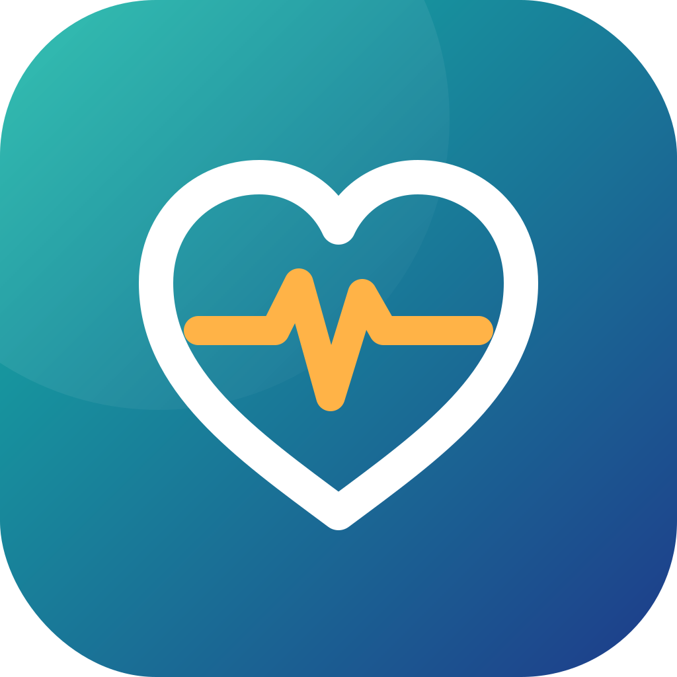
- Symbol: a white heart carrying a mango pulse line on a teal-to-indigo gradient — care, vitality and technology in one mark. Works as an app icon and as a horizontal wordmark where "My" is light and "Thuso" is bold in the gradient.
- Colours: Vital Teal #14B8A6 (health, freshness), Deep Indigo #1E3A8A (trust, technology), Mango #FFB347 (warmth, energy, the pulse), Slate #64748B and Soft Grey #F1F5F9 for interface and text.
- Typography: Poppins — geometric, friendly and highly legible on low-cost phones; light weight for "My", extra-bold for "Thuso".
- Tagline: "Help. Health. Home." Secondary: "Thuso is on the way."
- Name extensions: Thuso Nurse, Thuso Doctor, Thuso Kit, Thuso AI, Thuso Pass, Thuso Screen, Thuso Wear, Thuso Routine, Thuso Mom, Thuso Senior, Thuso Work, Thuso Corner, Thuso Academy, Thuso Money, Thuso Cover, Thuso Pod, Thuso Band, Thuso Home, Thuso Lab.

23. Immediate next steps
- Register MyThuso (Pty) Ltd and the MyThuso NPO; secure mythuso.co.za, mythuso.africa, trademarks and social handles; register on CSD.
- Open HWSETA, UIF LAP and corporate ESD conversations for kit and stipend funding.
- Appoint the Clinical Governance Lead and Medical Director.
- Open nurse recruitment; onboard first 50 Registered Nurses.
- Sign one pharmacy, one laboratory and the first 20 doctors for the review panel; apply for BHF practice numbers.
- Convene the Clinical Advisory Board and open conversations with two health insurers and two pharmaceutical market-access teams.
- Procure 50 standard kits and one area kit including rapid-test consumables; select AI model vendors for ECG, wound, urine and rapid-test reading; start Health Connect and Apple Health integration.
- Build and pilot v1; launch in three Johannesburg zones.

MyThuso — Help. Health. Home.

